**UNIVERSITY OF ENGINERRING AND**

**TECHNOLOGY,TAXILA.**

**BSC COMPUTER ENGINERRING**

Semester: 6th



**FINAL PROJECT REPORT**

**GROCERY LIST HOME APPLICATION**

* **Submitted By: ATTIA BATOOL**
* **Course Instructor: ENGR.SANA**
* **Lab Instructor: ENGR.SHAHID BUTTA**

**DATABASE MANAGEMENT SYSTEM (DBMS)**

**Grocery List Home Application**

**Abstract**

The **Grocery List Home Application** (GLHA) helps manage grocery items efficiently, reducing errors and missing stock information. It stores item details like name, quantity, and category in a database. The system allows users to add, view, and delete items through a simple interface. Using **PHP** and **MySQL**, it performs SQL queries to manage inventory data. This project demonstrates the practical use of **Database Management System** (DBMS) concepts for efficient inventory management.

**Problem Statement**

Managing grocery items manually often leads to errors, missing stock information, and a lack of proper records. Shopkeepers or households may forget which items are low or which category they buy the most. To solve this, I developed a **Grocery Inventory Management System** that stores, manages, and displays grocery item records using a database-driven web application.

**Objectives**

* To design a database that stores grocery item details including name, quantity, and category.
* To provide a user-friendly interface for adding, viewing, and deleting items.
* To implement backend logic using **PHP** and **MySQL**.
* To perform **SQL queries** to manage the inventory efficiently.
* To apply DBMS concepts practically in a small but meaningful project.

**Business Rules**

1. **A user can have multiple grocery items** — One-to-Many relationship.
2. **Each item belongs to one category** — Many-to-One relationship.
3. **Each category can contain multiple items** — One-to-Many.
4. **Each item is added by a specific user** — Many-to-One.
5. **Users can generate multiple expense reports** — One-to-Many.
6. **Each expense report records details of one item** — Many-to-One.
7. **Expense reports are also linked to the user who generated them** — Many-to-One.

**Technologies Used**

|  |  |
| --- | --- |
| **Component** | **Tool/Language** |
| Frontend | HTML, CSS |
| Backend | PHP |
| Database | MySQL |
| Server | XAMPP (Apache + MySQL) |

**System Modules**

1. **Login System**
   * Simple login with username (for session control).
   * Used $_SESSION to maintain active users.
2. **Add Item Page**
   * Form to add item name, category, and quantity.
   * Data inserted into MySQL database.
3. **Item Dashboard**
   * Displays all items from the database.
   * Shows total items and per-category counts.
4. **Logout Page**
   * Session destruction with username confirmation.
5. **Category Analysis**
   * Counts how many items exist in each category (e.g., Fruit, Dairy).
   * Shows percentages using simple PHP logic.

**System Architecture**

This project follows a **2-Tier Architecture**:

* **Presentation Tier:** The front-end of the system, developed using HTML and CSS, runs in the user's browser and handles UI/UX.
* **Data Tier (Application + Database):** The back-end is built with PHP and MySQL, where PHP handles business logic and directly communicates with the MySQL database to store, retrieve, and manipulate data.

**Data Flow Diagram (DFD)**

**Entity Relationship (ER) Diagram:**

**Relational Model:**

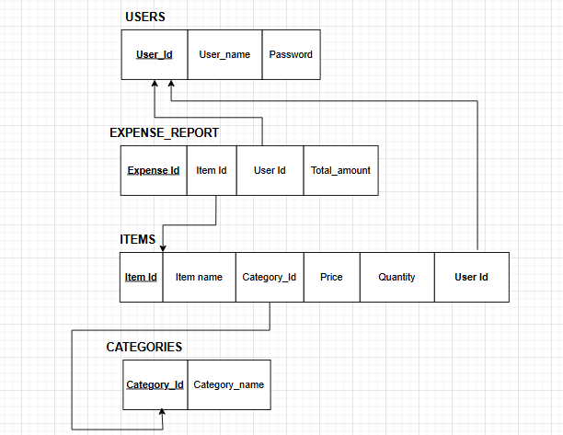

**Database Schema Overview**

1. **Schema Name:** grocery_db
   * A single schema used to define all tables and relations.
   * Normalized to 3NF to avoid redundancy.
2. **Views Implemented:**
   * **view_all_items:** Displays joined data from items and categories.
   * **view_category_summary:** Shows item count per category.
   * **view_expense_report:** Retrieves expense info with item names and dates.

**Database Design**

**Database Name: grocery_db**

The system uses a normalized schema to manage grocery inventory, user sessions, categories, and expenses efficiently.

**Tables Overview**

1. **users**
   * Stores login information.
   * Fields: id, username
   * Used for session control and authentication.
2. **items**
   * Manages grocery items.
   * Fields: id, name, category, quantity,price
   * Core table for inventory operations.
3. **categories**
   * Organizes items into types (e.g., Fruits, Snacks).
   * Fields: id, name
   * Supports filtering and grouping.
4. **expense_reports**
   * Tracks purchase records and costs.
   * Fields: id, item_id, amount, date
   * Helps analyze monthly expenses.

**Working Steps**

1. **User opens the login page**, enters username.
2. On successful login, **user is redirected to item dashboard**.
3. **User can add new items** via form → Item is stored in items table.
4. All added items are displayed in a **table format** on dashboard.
5. A summary section shows **total items and per-category counts**.
6. If user clicks **Delete**, item is removed from the database.
7. When logout is clicked, user enters credentials again.

**Results**

* Items are properly inserted, displayed, and deleted from the MySQL database.
* I successfully applied **Insert, Select, Delete, and Count** queries.
* Implemented session-based login/logout system.
* Displayed grocery data dynamically from the database.
* Category analysis helps visualize which items are most used.

**login_signup_page**

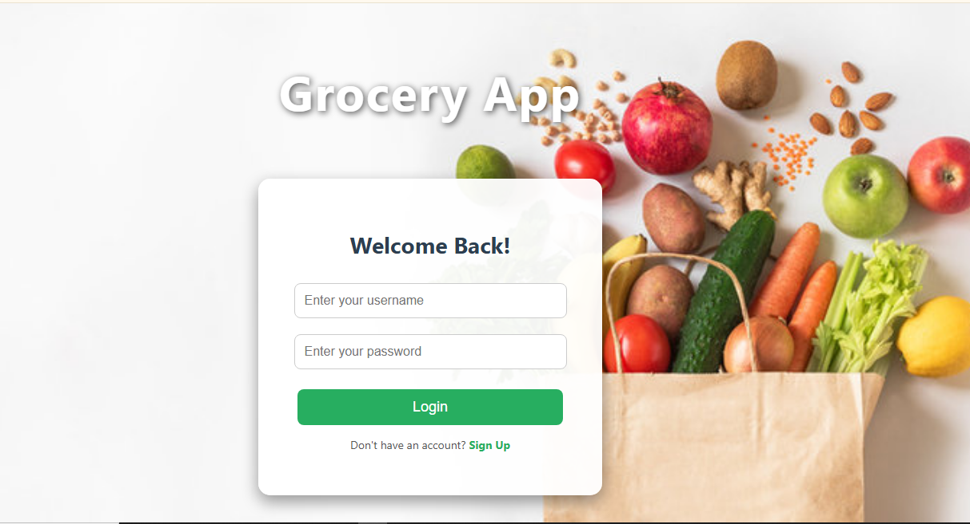

**Figure 01:**This is the main entry point of my project.Users can log in or sign up to access the system securely.

**home_dashboard**

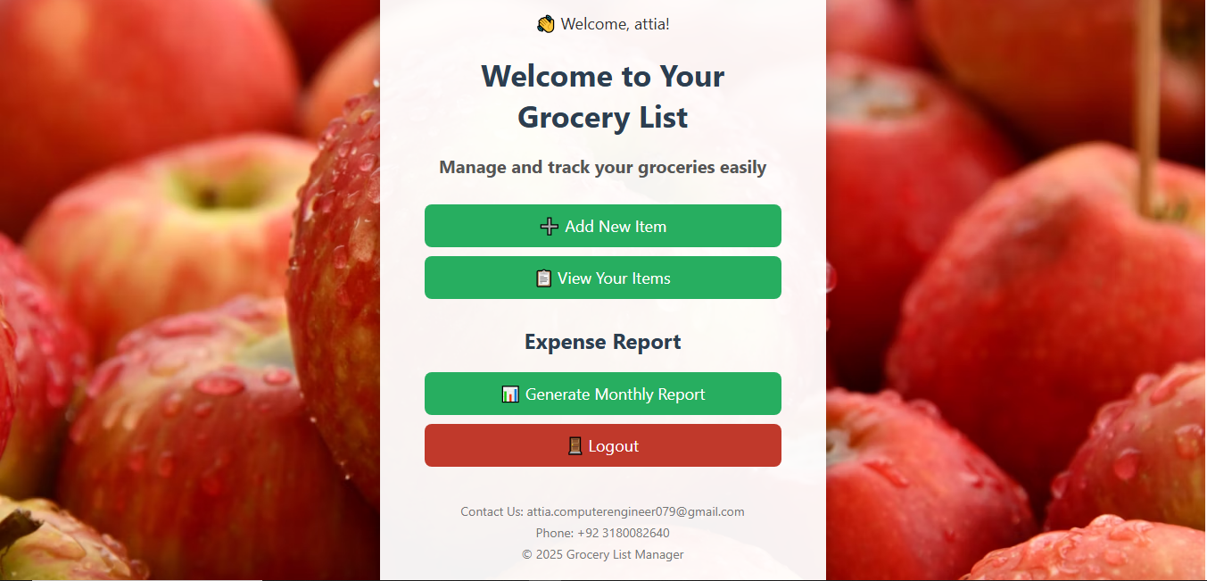  
**Figure 02:**This is the home page after login.It has buttons to add items, view items, generate reports, and log out.

**Add_items_page**

**Figure 03:**I created this form for adding new grocery items.Users can input item name, category, and quantity.

**Database View**

**Figure 04:** Item details stored in a database.

**view_items_page**

**Figure 05**:This page displays all added grocery items.Items are shown in a table with category and quantity.

**Reports_page**

**Figure 06**:This page shows generated reports.It includes category-wise analysis and total item count.

**logout_page**

**Figure 07:**This is the logout confirmation page.It safely ends the session and redirects to the login screen*.*

**DBMS Concepts Applied**

|  |  |
| --- | --- |
| **DBMS Concept** | **How It Was Used** |
| Table Design | Used CREATE TABLE with suitable data types |
| Primary Key | Applied on both users and items table |
| DML Commands | Used INSERT, SELECT, DELETE queries |
| Query Filtering | Applied WHERE condition to manage specific records |
| Aggregate Functions | Used COUNT(*) for category-based analysis |

**Learnings & Improvements**

* I learned how to **connect PHP with MySQL** and perform basic DB operations.
* Understood the practical role of a database in a web application.
* Improved logic building using SQL and condition-based filters.
* I plan to add:
  + **Update item** feature
  + **User authentication with password**
  + **Category-wise charts**

**Conclusion**

This project helped me implement key concepts from my **Database Management System (DBMS)** course in a practical way. I handled table design, SQL queries, and user sessions effectively. It is a useful system that can help small businesses or households manage grocery items digitally.

This was a valuable hands-on experience and a strong step toward understanding backend database handling and integration with frontend web interfaces.